# Android App Development

## CodeIt

## Register

**Note**: Please use Android Version 10 or above for **appetize.io** emulator

Online Emulator Link: <https://appetize.io/app/4bnfcn50me7fg286frrbk2apar>

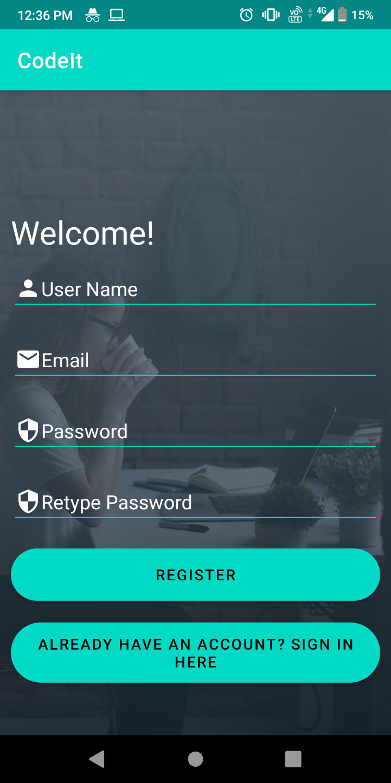

## Login

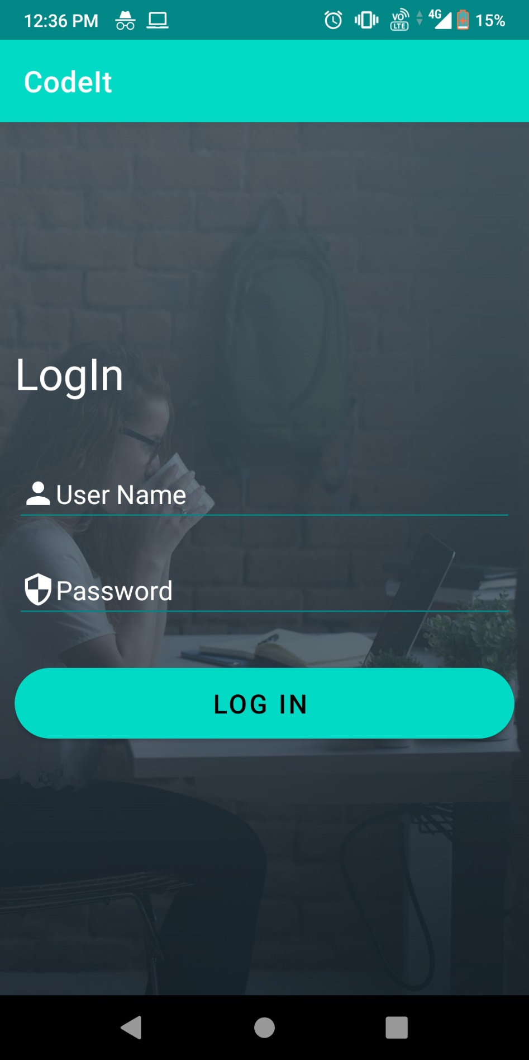

## Recycler View

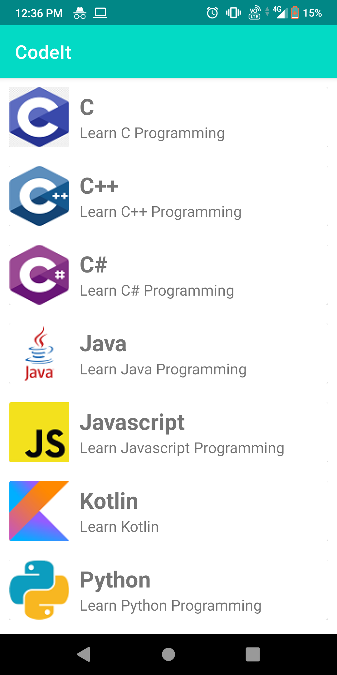

## Detail View

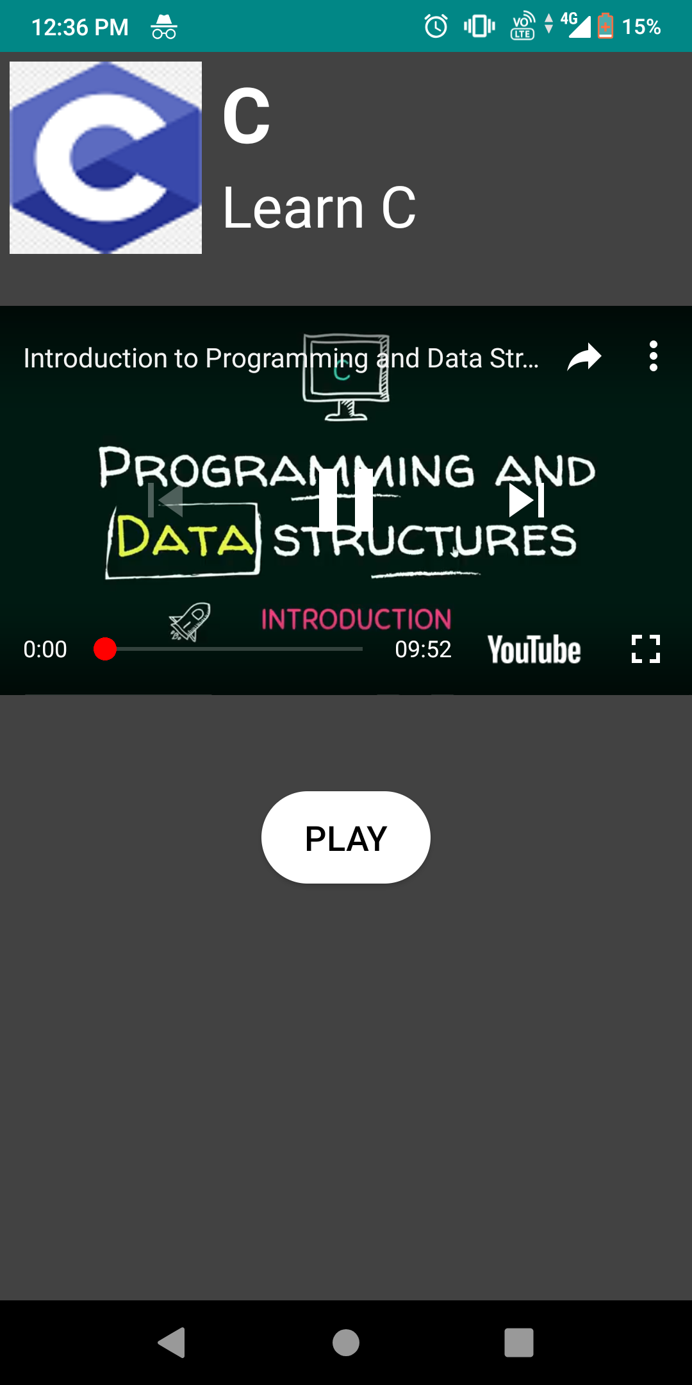

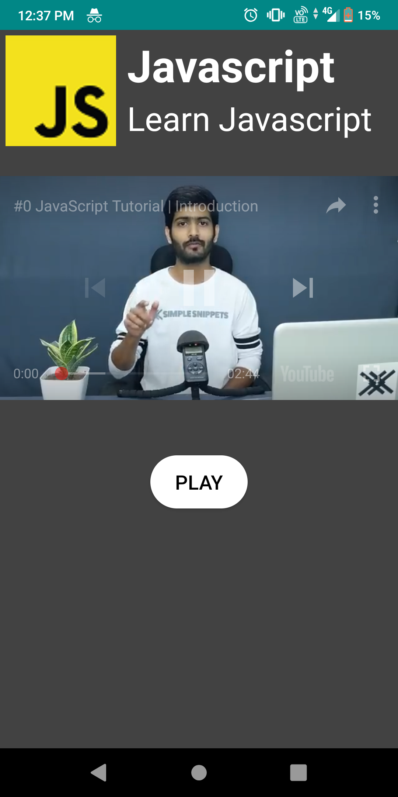

## Hindi Translation

## Register

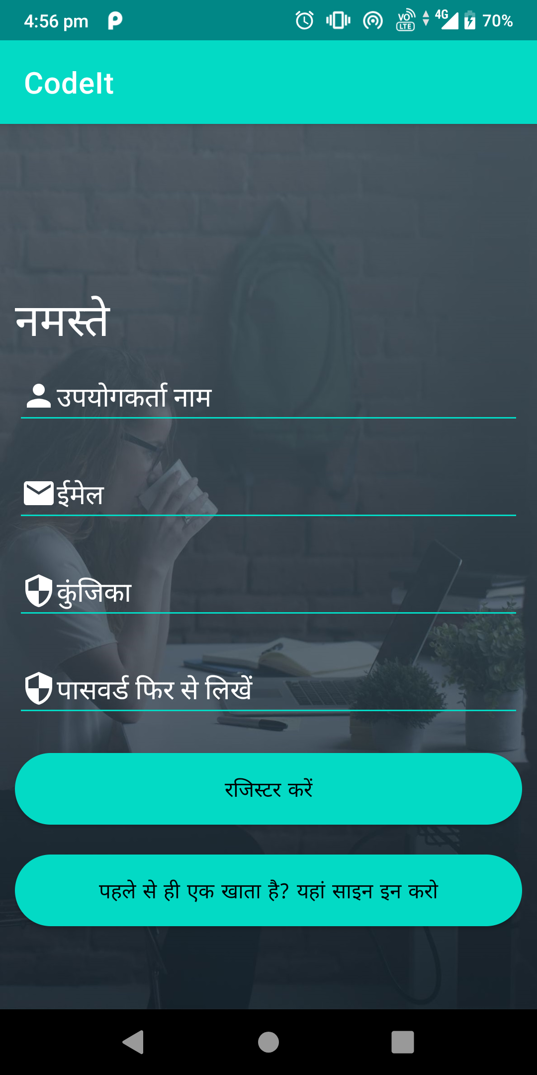

## Login

